FSK 116 – ANALYSIS MODELS

CHAPTER 5

5.7. AM: Newton II
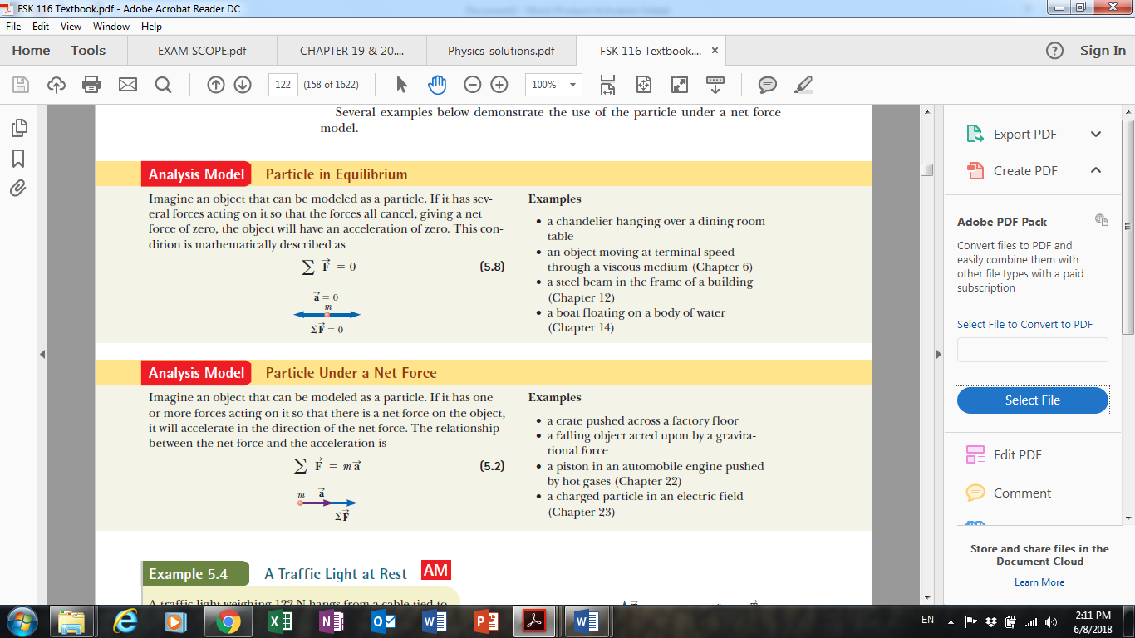

CHAPTER 6

6.1. Extending the particle in uniform circular motion model
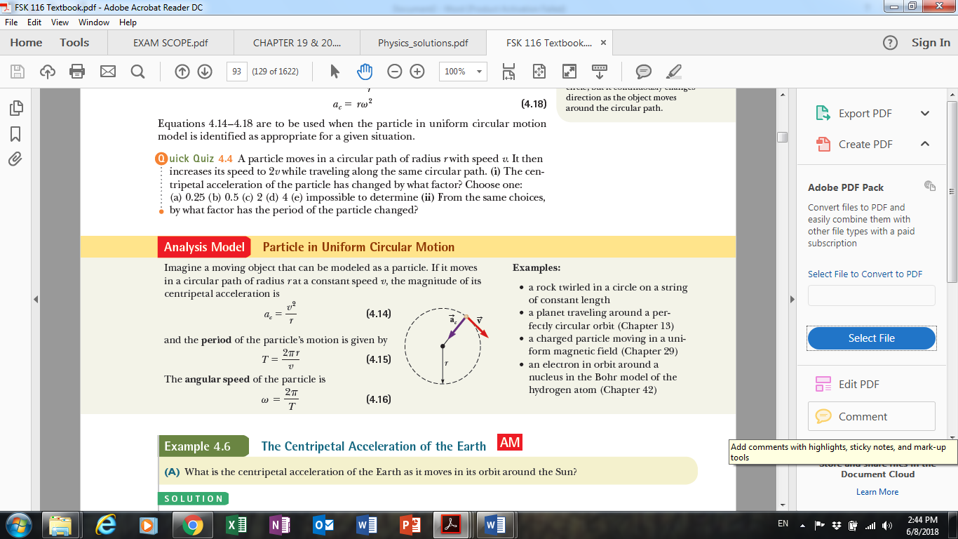
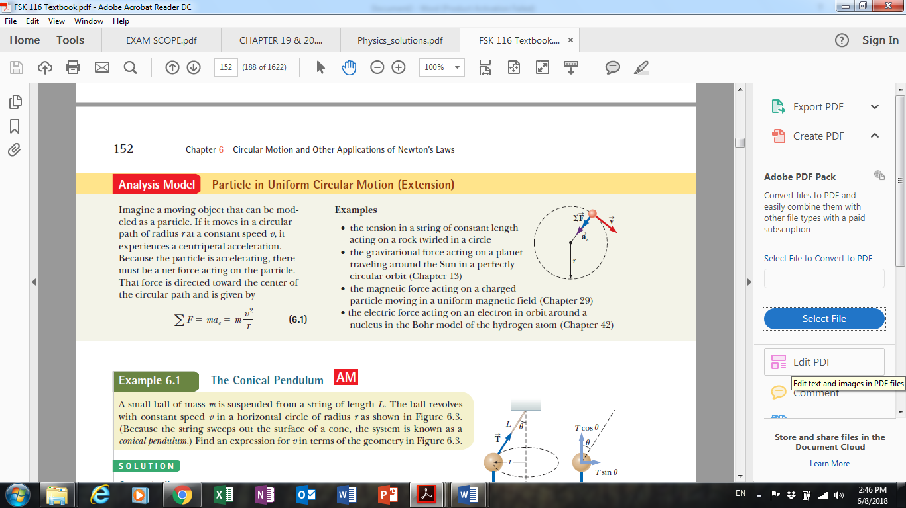

CHAPTER 8

8.1 AM: Nonisolated system (energy)
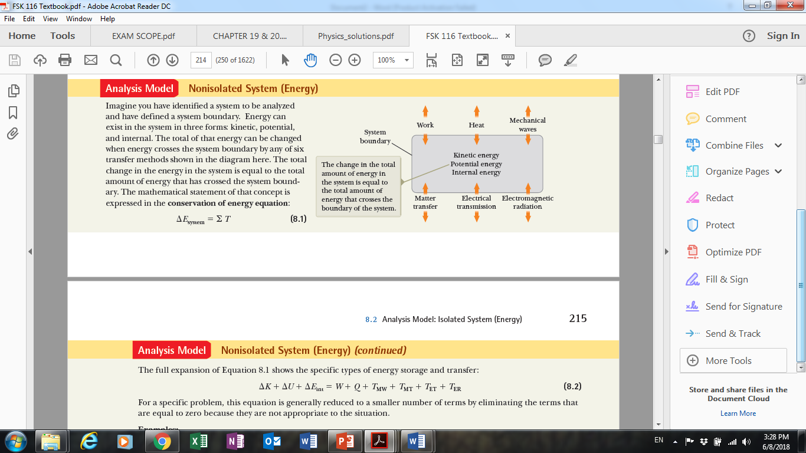
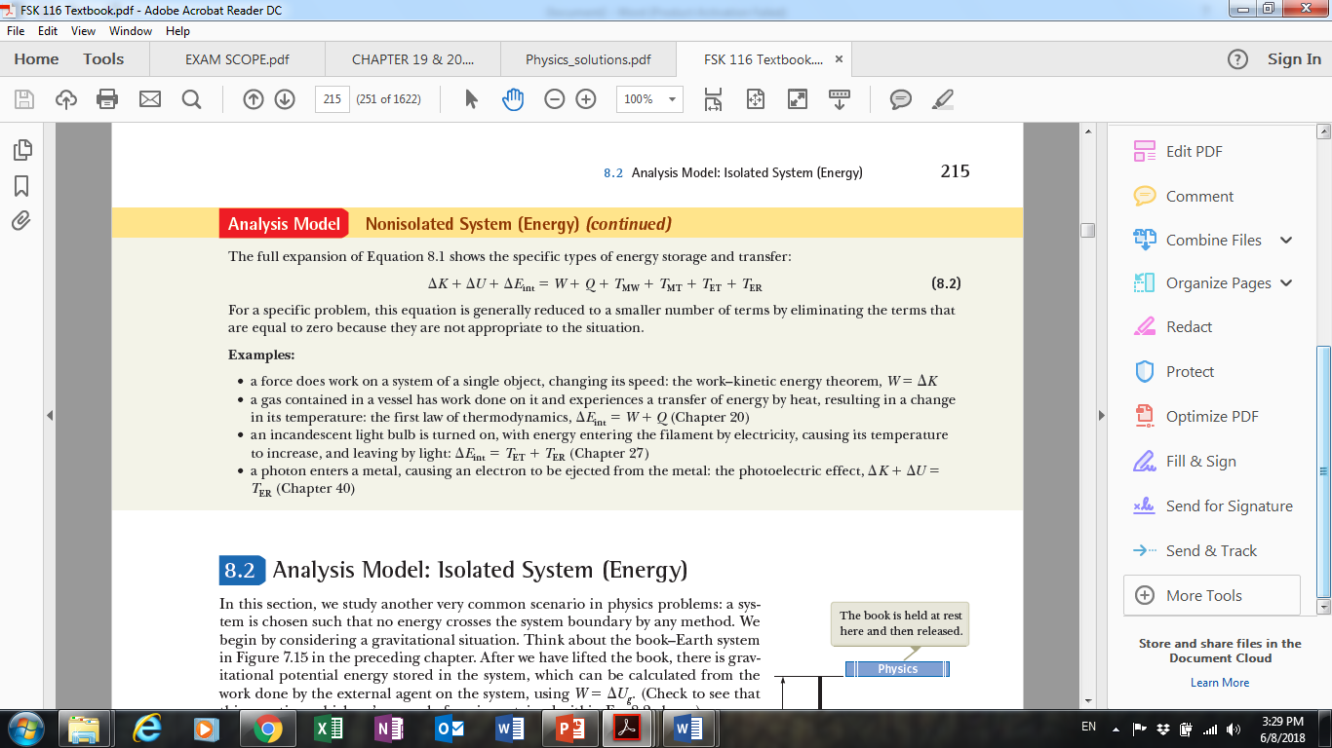

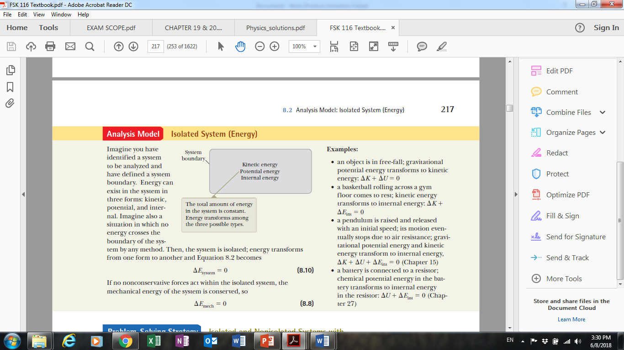
8.2. AM: Isolated system (energy)

CHAPTER 9

9.2. AM: Isolated system (momentum)
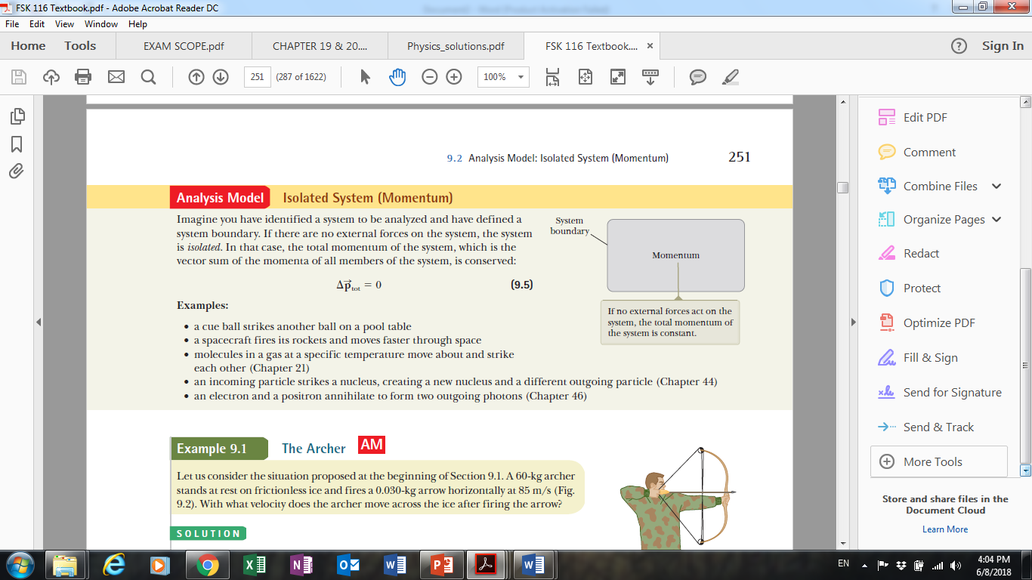

9.3. AM: Nonisolated system (momentum)
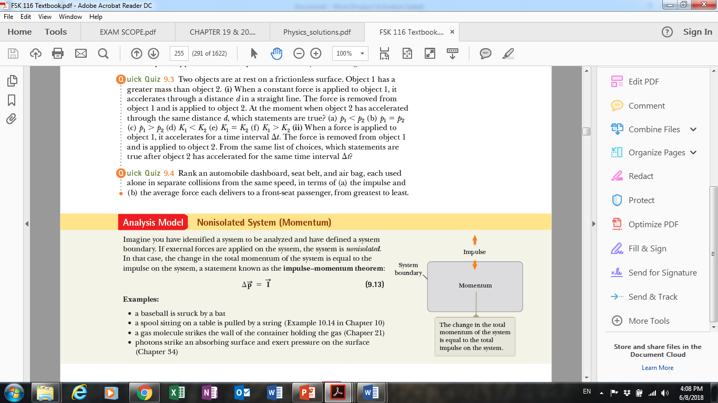

CHAPTER 10

10.2. AM: Rigid object under constant angular acceleration
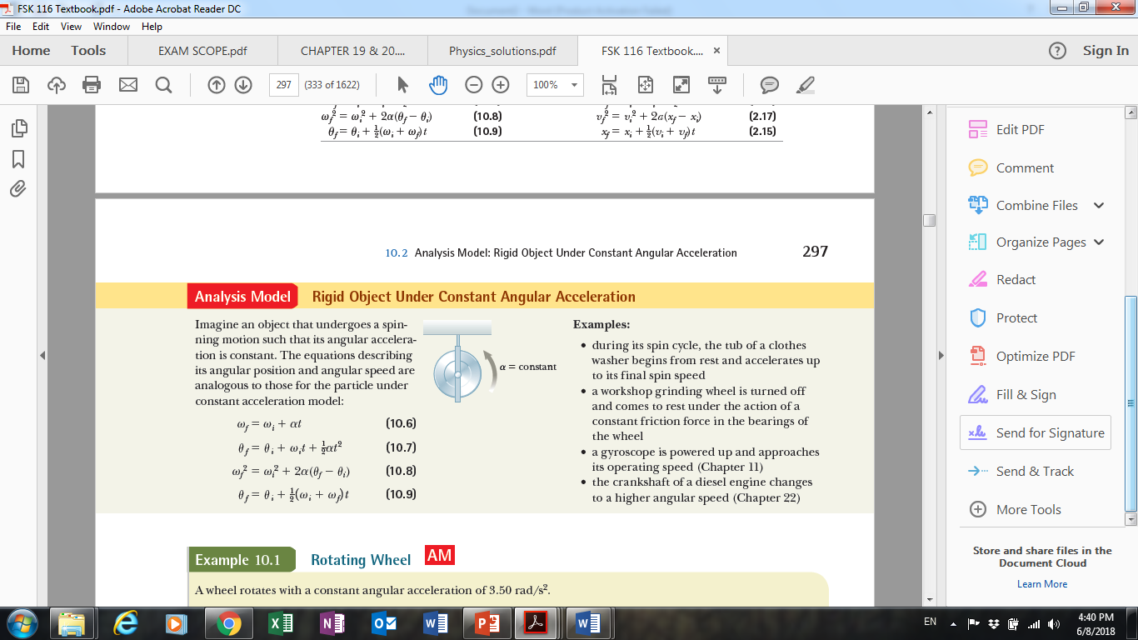

10.5. AM: Rigid object under a net torque
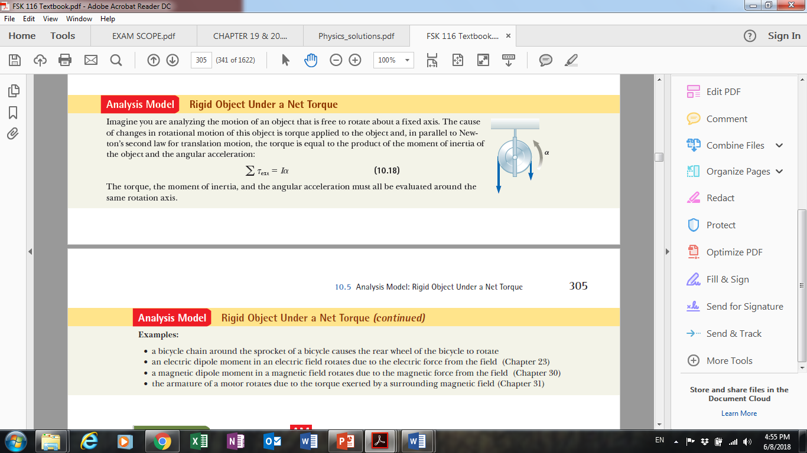

CHAPTER 15

15.2. AM: Particle in SHM
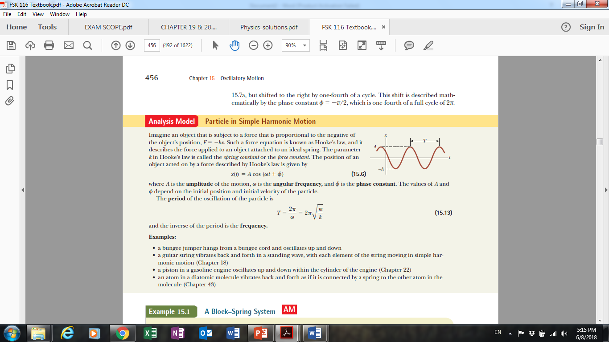

CHAPTER 16

16.2. AM: Traveling wave
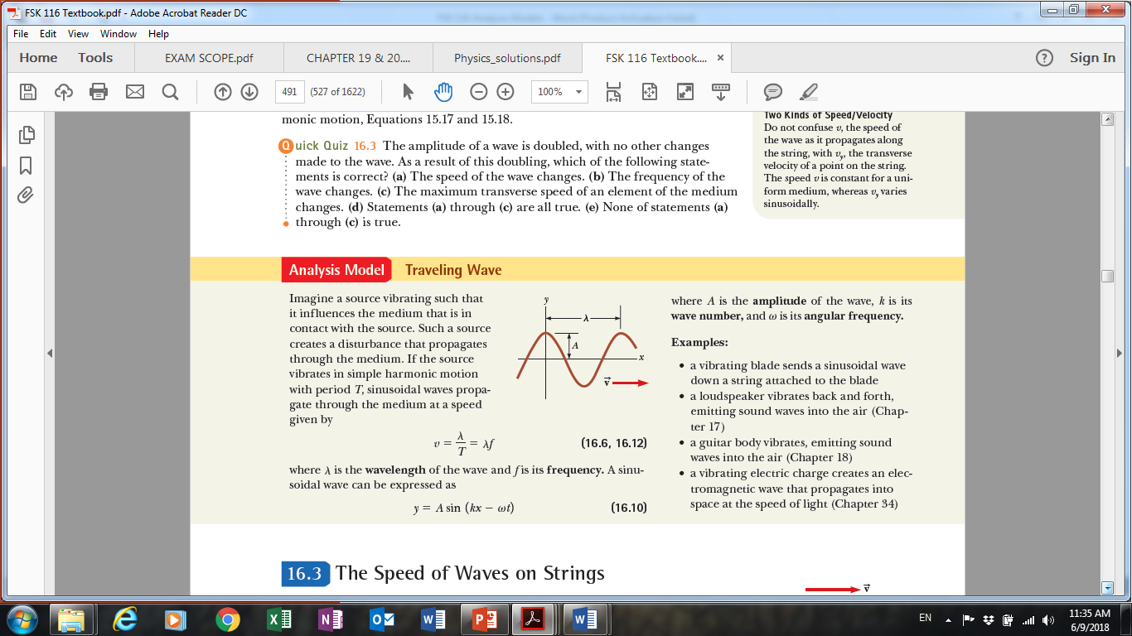

CHAPTER 18

18.1. AM: Waves in interference
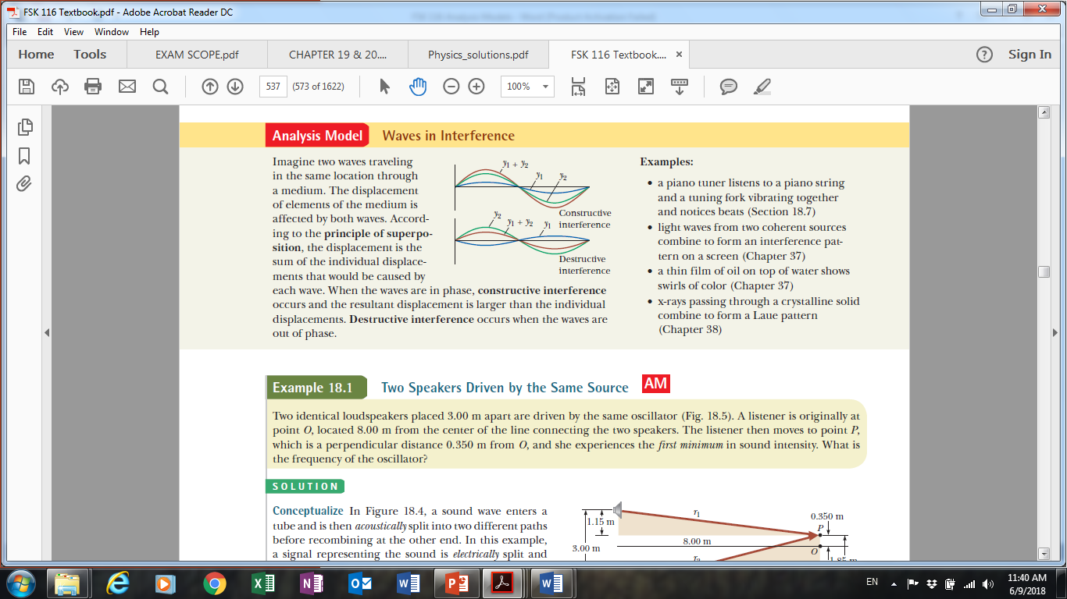

18.3. AM: Waves under boundary conditions
